**Excel Assignment - 11**

1. Use the below table for the following Questions.

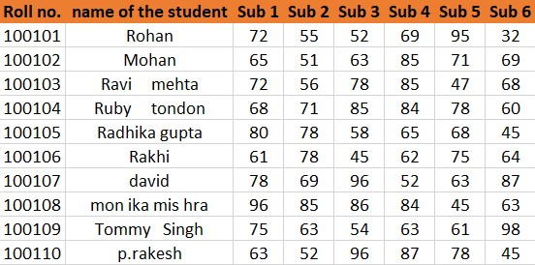

1. Find the Minimum Marks and Maximum marks scored by each student.

Ans. = MIN (C2:H2) and drag it for all

2. Calculate the totals for each student, and use conditional formatting to highlight the top students who have scored more than 480.

Ans. =SUM (C2:H2) and drag it for all, then to highlight the cell greater than 480 go to “HOME” tab, then styles ribbon and choose the “CONDITIONAL FORMATTING”. Then after chose the “GREATER THAN” option.

3. Calculate the length of the names of each student.

Ans. =LEN (B2) and drag it for all

4. Replace the Name Rakhi with Rocky. Use Formulas

Ans. =IF (B2 = "Rakhi”, Rocky", B2) and drag it for all

5. Combine the Roll Numbers and Names. Use formulas. The end result should look like below.

100101Rohan

Ans. =CONCATENATE (A2, B2)

6. As you can see that some names have spacing issues. Use Formulas to correct that spacing. Also, ensure that the names and surnames start with a capital letter.

Ans. First use =TRIM (B2) to remove all extra spaces. To ensure the names and surnames start with capital letters use

=PROPER (O2) and drag it for all